 | 26.10.22 Editors - Properties Editor - Particle Properties Tab - Hair - Render panel
Table of content
Render Panel 2
Render As 2
All render methods 2
Show Emitter 2
Render as None 3
Render as Halo + Line 3
Scale 3
Scale Randomness 3
Material 3
Coordinates System 3
Extra sub tab 3
Parents Particles 3
Unborn 3
Dead 3
Render as Path 4
Scale 4
Scale Randomness 4
Material 4
Coordinates System 4
Path subpanel 4
B-Spline 4
Steps 4
Timing subpanel 4
Absolute Path Time 4
End 4
Random 4
Extra subpanel 5
Parents Particles 5
Unborn 5
Dead 5
Render as Object 5
Scale 5
Scale randomness 5
Object Sub tab 5
Instance Object 5
Global Coordinates 5
Object Rotation 5
Object Scale 5
Extra sub tab 5
Parents Particles 5
Unborn 6
Dead 6
Render as Collection 6
Scale 6
Scale randomness 6
Collection Sub tab 6
Instance Collection 6
Whole collection 6
Pick Random 6
Global Coordinates 6
Object Rotation 6
Object Scale 6
Use Count 6
Active Dupli Object Index list 7
Drag Handler 7
Search Field 7
Invert 7
Sort by Name 7
Revert 7
Copy Particle Dupliobject 7
Remove Particle Dupliobject 7
Move Up / Down Dupli Object 7
Refresh Dupli Objects 7
Count 7
Extra sub tab 7
Parents Particles 7
Unborn 7
Dead 8

Render Panel

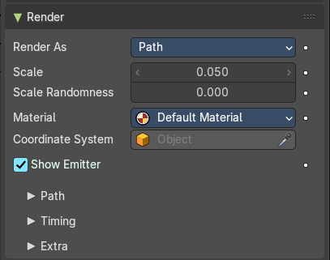
Hair particles can be rendered as a Path. And it can render Objects or collections as the hair particles.

Render As
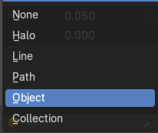
Render the particles with different methods.

All render methods

Show Emitter
Render the particle emitting mesh. This does not affect viewport rendering!

Render as None

Don't render the particles.

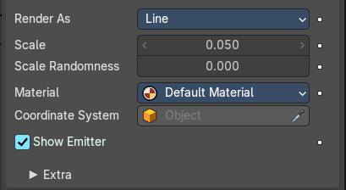
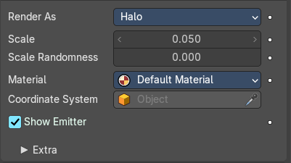
Render as Halo + Line
Render the hair particles as a halo.

Scale
The size of the particles.

Scale Randomness
Give the particle size a random variation.

Material
Set which of the object’s materials is used to shade the particles.

Coordinates System
Use a different object’s coordinates to determine the birth of particles.

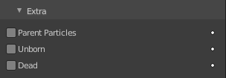
Extra sub tab

Parents Particles
Render also parent particles if child particles are used. Children have a lot of different deformation options, so the straight parents would stand between their curly children. So by default Parents are not rendered if you activate Children. See Children.

Unborn
Render particles before they are born.

Dead
Render particles after they have died. This is very useful if particles die in a collision Die on hit, so you can cover objects with particles.

Render as Path
Render the hair particles as paths.

Scale
The size of the particles.

Scale Randomness
Give the particle size a random variation.

Material
Set which of the object’s materials is used to shade the particles.

Coordinates System
Use a different object’s coordinates to determine the birth of particles.

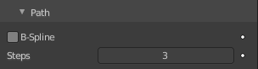
Path subpanel

B-Spline
Interpolate hair using B-splines. This may be an option for you if you want to use low Render values. You loose a bit of control but gain smoother paths.

Steps
Set the number of subdivisions of the rendered paths (the value is a power of 2). You should set this value carefully, because if you increase the render value by two you need four times more memory to render. Also the rendering is faster if you use low render values (sometimes drastically). But how low you can go with this value depends on the waviness of the hair (the value is a power of 2). This means 0 steps give 1 subdivision, 1 give 2 subdivisions, 2 –> 4, 3 –> 8, 4 –> 16, … n –> n2.

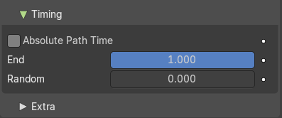
Timing subpanel

Absolute Path Time
Path timing is in absolute frames.

End
End time of the path.

Random
Give the path length a random variation.

Extra subpanel

Parents Particles
Render also parent particles if child particles are used. Children have a lot of different deformation options, so the straight parents would stand between their curly children. So by default Parents are not rendered if you activate Children. See Children.

Unborn
Render particles before they are born.

Dead
Render particles after they have died. This is very useful if particles die in a collision Die on hit, so you can cover objects with particles.

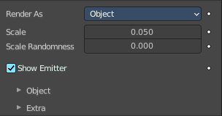
Render as Object
Render collections instead of the paths of the hair particles.

Scale
The scale factor of the object.

Scale randomness
Give the particle size a randomness.

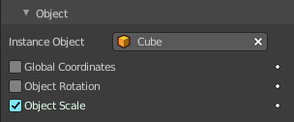
Object Sub tab
Choose the object to render instead of the path.

Instance Object
Pick the object that you want to use as the particle.

Global Coordinates
Use the global coordinates of the object for duplication. This sets the particles to the position of the chosen object.

Object Rotation
Use the rotation of the object for duplication.

Object Scale
Use the scale of the object for duplication.

Extra sub tab

Parents Particles
Render also parent particles if child particles are used. Children have a lot of different deformation options, so the straight parents would stand between their curly children. So by default Parents are not rendered if you activate Children. See Children.

Unborn
Render particles before they are born.

Dead
Render particles after they have died. This is very useful if particles die in a collision Die on hit, so you can cover objects with particles.

Render as Collection
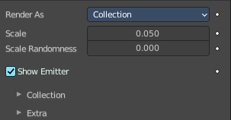
Render the content of a collection instead of the paths of the hair particles.

Scale
The scale factor of the object.

Scale randomness
Give the particle size a randomness.

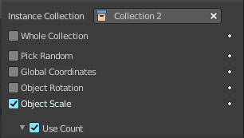
Collection Sub tab
Choose the object to render instead of the path.

Instance Collection
Pick the collection that you want to use as the particle.

Whole collection
Use the whole collection at once.

Pick Random
Pick objects from the collection randomly.

Global Coordinates
Use the global coordinates of the object for duplication. This sets the particles to the position of the chosen object.

Object Rotation
Use the rotation of the object for duplication.

Object Scale
Use the scale of the object for duplication.

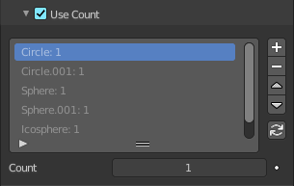
Use Count
Use objects multiple times in the collection.

Active Dupli Object Index list
The list with the objects from the collection. The number behind the object tells you how often this object is used in the particles, relative to the other objects.

Drag Handler
The two vertical lines at the end is a handler with which you can expand the list.

Search Field

You can expand a search field at the bottom of the list. Type in your term and hit enter to filter for your term.

Invert
Exclude the search term instead of searching for it.

Sort by Name
Sort the List by name.

Revert
Revert the list. The last list item becomes the first, and vice versa.

Copy Particle Dupliobject
Duplicate the current dupli object.

Remove Particle Dupliobject
Remove the selected dupli object.

Move Up / Down Dupli Object
Move the dupli object up or down in the list.

Refresh Dupli Objects
Refresh the list of dupli objects and their weights.

Count
The number of times this object is repeated with respect to other objects.

Extra sub tab

Parents Particles
Render also parent particles if child particles are used. Children have a lot of different deformation options, so the straight parents would stand between their curly children. So by default Parents are not rendered if you activate Children. See Children.

Unborn
Render particles before they are born.

Dead
Render particles after they have died. This is very useful if particles die in a collision Die on hit, so you can cover objects with particles.

